ATTEN Power V2.0 Software operation guide

- Software installation
  - Download app from www.atten.com.cn/www.atten.com
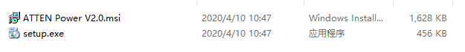
  - Run setup.exe App，Due to the different system environments, the software may trigger some security monitoring software to prompt security warnings, allowing the software to run directly， Click Next to go ahead

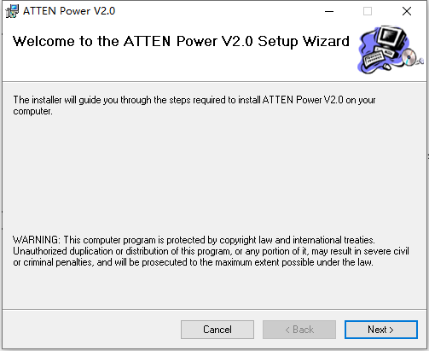

  - Select the software installation location, it is recommended to install it on the D drive, click Next to proceed to the next step
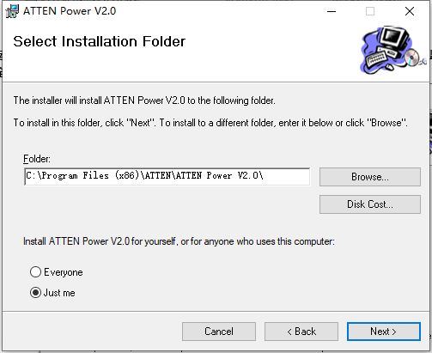

  - Continue to click Next to proceed to the next step until the software installation is complete, click Close to exit the software installation interface.
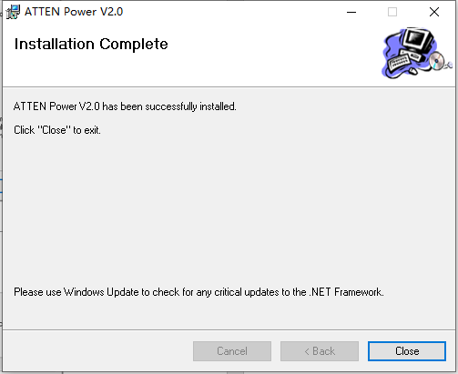

- Software setting

- Automatically connect power equipment
Connect the power supply communication cable to the power supply,turn on the power switch, and click the icon on the computer desktop， Run the software, the software will automatically search for the power supply device until the connection is completed, as shown in the figure below:

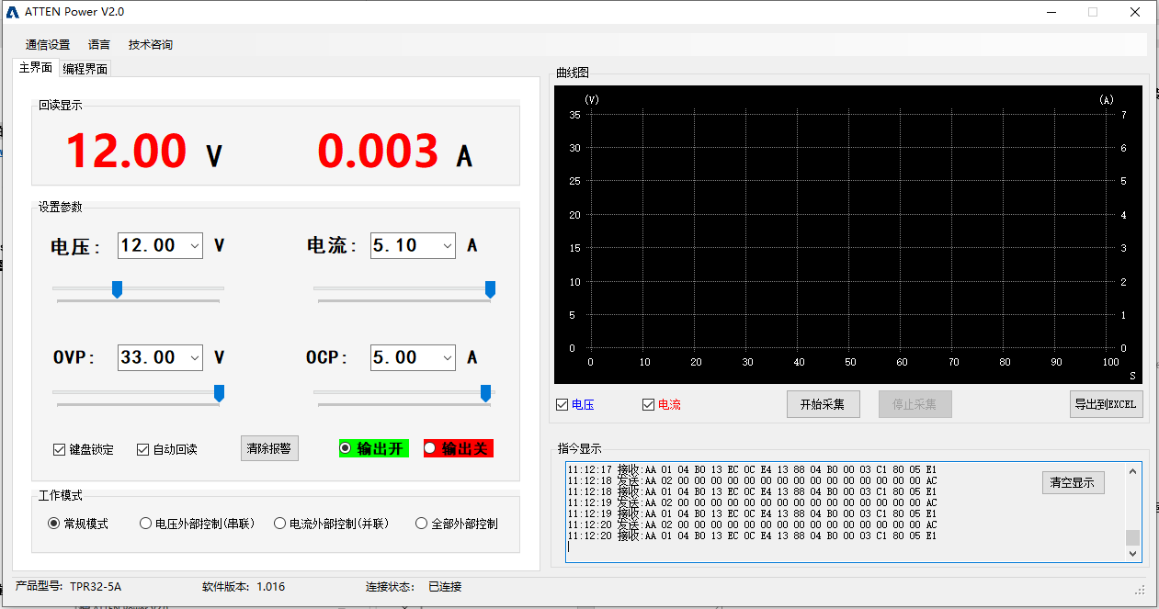

- Manually connect the power supply
When the software cannot automatically find the power supply device, you can manually connect it. Click "Communication Settings" in the upper left corner of the software to open the secondary menu, and then click "Communication Parameters" to open the parameter setting window, as shown in the figure below:
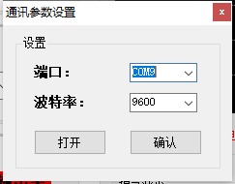

Select the communication port that the power supply is connected to select the baud rate "9600", click the "Open" button, and then click the "OK" button to close the window and return to the main interface. As shown below:
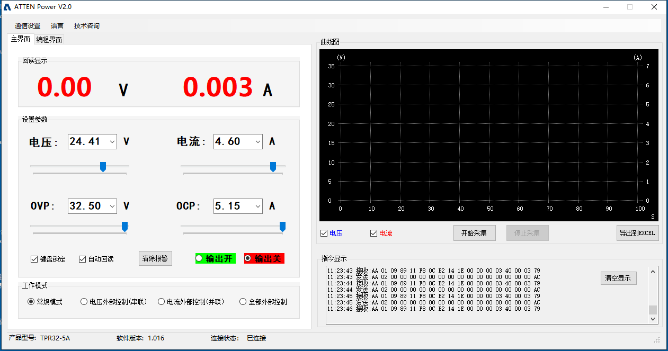

Click the "Output Off" button again, and the software will recognize the power supply and connect successfully

- Use of software

  - Go to the main interface of the software, when the power supply device is successfully connected, you can start to set and display the current power supply working status and parameters
  - Read back the display area to display the actual output voltage and load working current of the current power supply, as shown in the figure below.
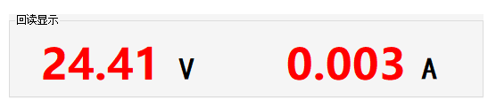

  - In the setting parameter area, you can set the set voltage, set current, OVP set or OCP set value of the power supply. Click the "output on" and "output off" radio buttons to turn on or off the power output.

When you need to continuously read the current installed state of the power supply, you need to check the "Automatic readback" option.
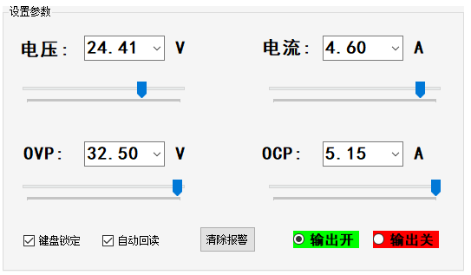

  - When you need to switch to series-parallel or external control mode, you can set it in the working mode panel (for detailed working mode introduction, please refer to the product manual)

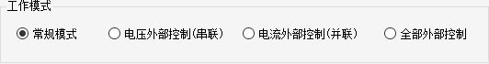

  - Curve display function

The graph function provides a data collection function, which can collect and display the output voltage or current working current at the same time, and can be exported to an Excel file.

When you need to use it, you need to manually click the "Start Collection" button to check whether to display the voltage curve or the current curve.
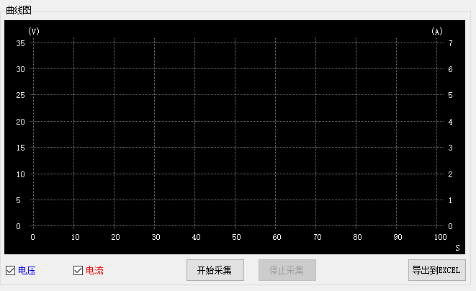

When the data collection is completed, you can click the "Stop Collection" button to complete the data collection, and click "Export to EXCEL" to save the collected data as an EXCEL file for analysis.

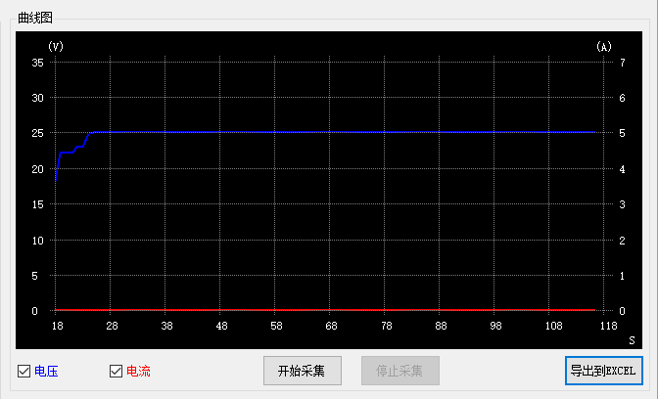

  - Instruction display window

This window can display the instructions sent or received by the software to the power supply, which is convenient for analysis and assist users in developing applications.
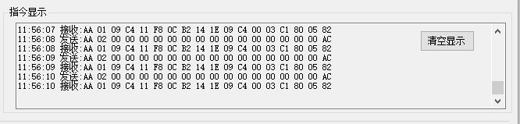

  - Programming function

In the current interface, the user can edit the form, and can control the power supply device to output voltage, current, and duration according to user requirements
It is used for load debugging or aging and durability test, etc.

The user can set the number of loop runs of the form, or select the "X" value for an infinite loop, and then click "Start" to run the program

